**VECTR v7.1.1 Feature Breakdown**

Table of Contents

Advanced Reporting Features 2

# Advanced Reporting Features

What is it?

Allows for more granular control of reporting to show the exact statistics needed for your reports.

How does it work?

From the Reporting screen, make sure the Filters screen is visible, then click the Report Filters button:

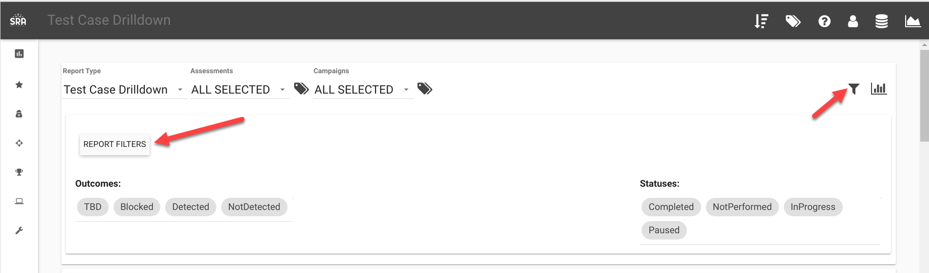

All the major categories of filters are displayed in Tabs across the top:

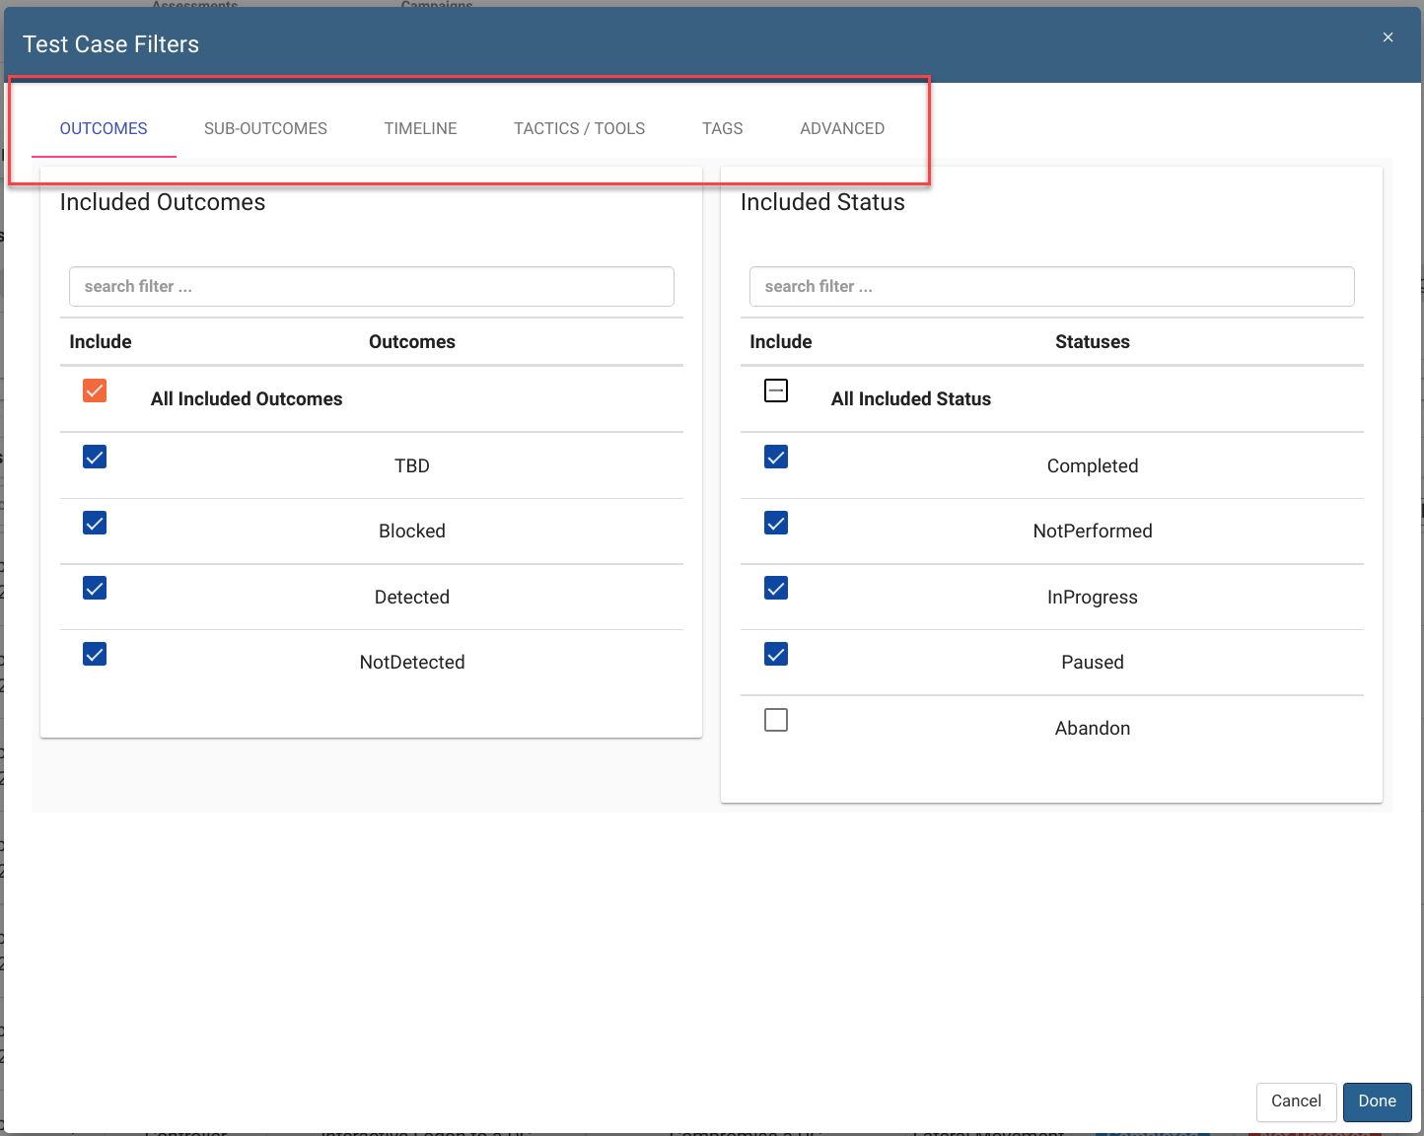

These applied filters will be used against all Report Type pages. For example, if you want to see all tests that have an Expected Defensive Layer of SIEM:

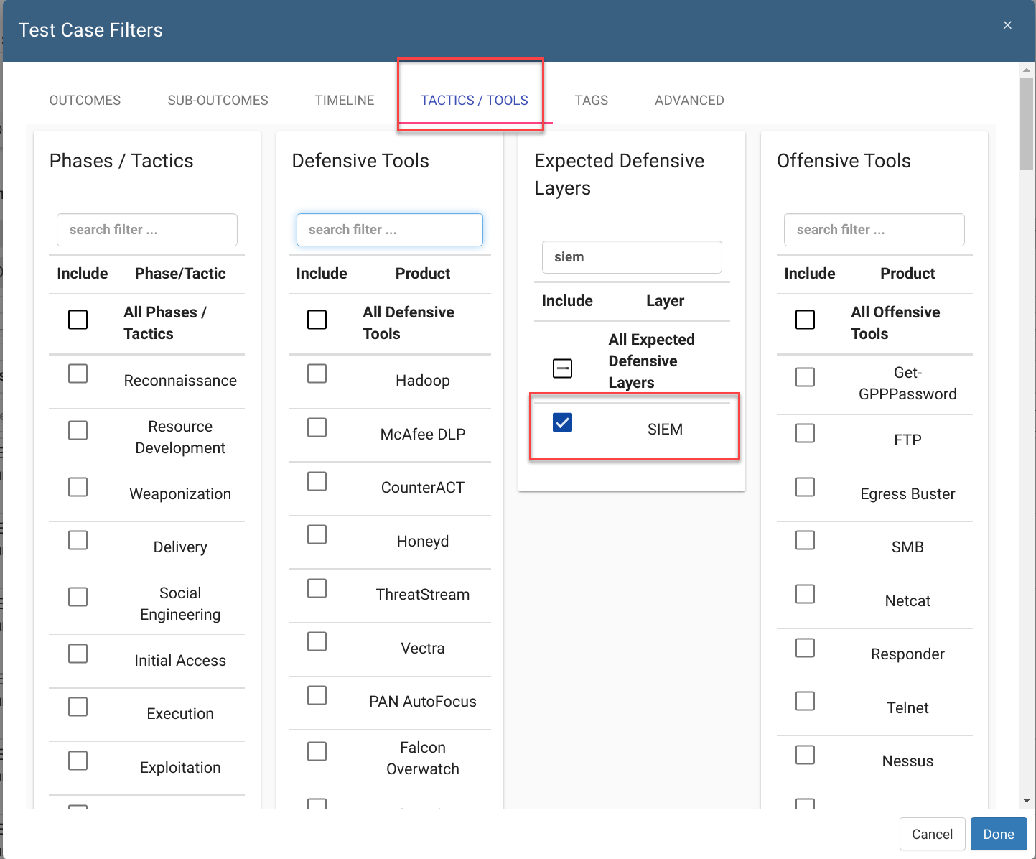

This will only retrieve data that has a Test Case “Defenses” that contains SIEM:

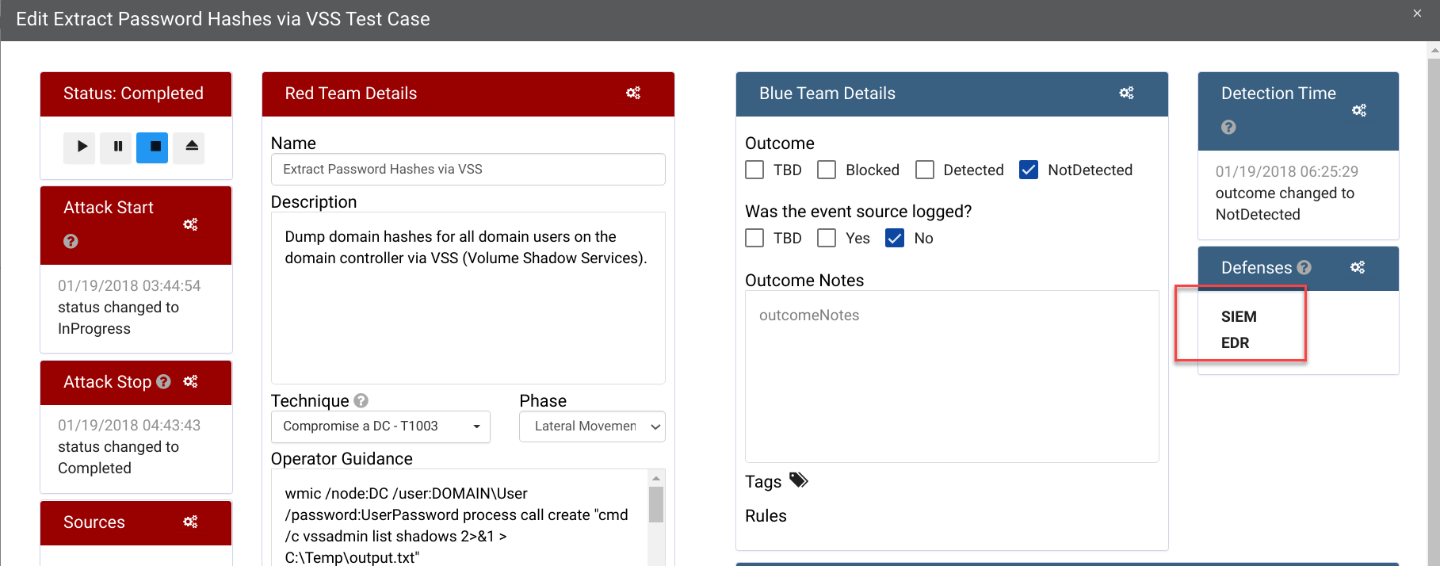

How can this feature help me?

This allows for more granular control of reporting. Here is a guide for how the reporting filters map up to the Test Case fields:

Filter:

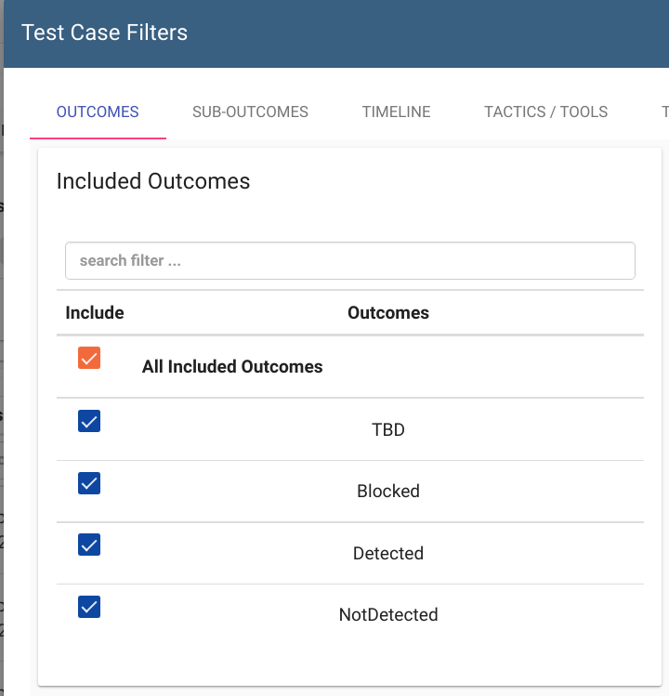

Field:

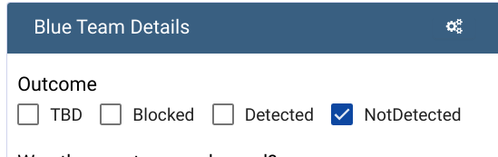

Filter:

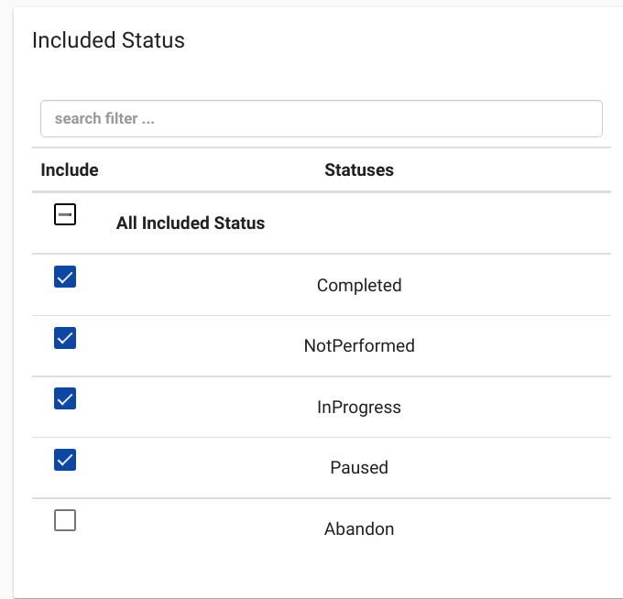

Field:

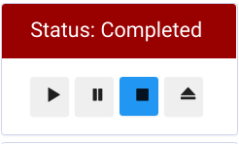

Filter:

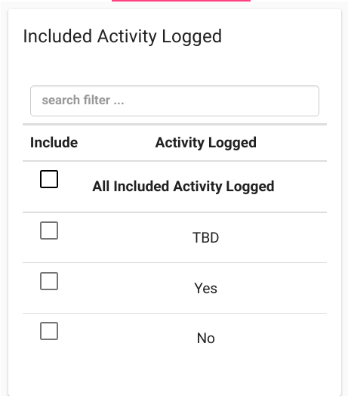

Field:

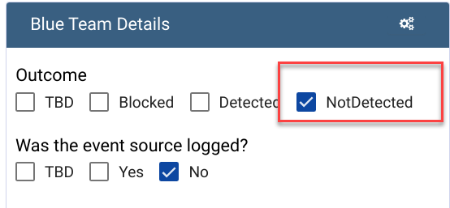

Note:

Activity Logged will only apply for NotDetected Outcome.

Filter:

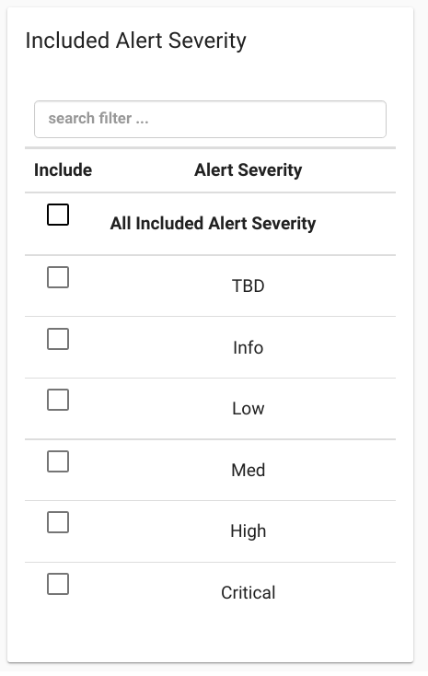

Field:

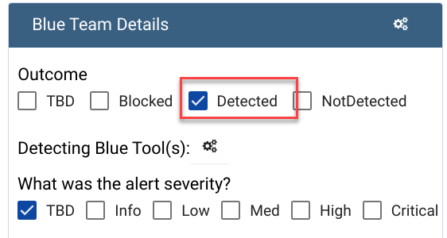

Note:

Alert Severity will only apply for Detected Outcome.

Filter:

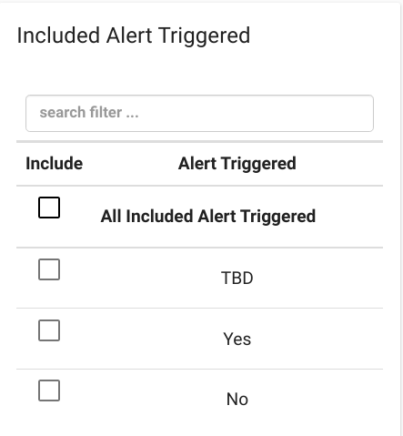

Field:

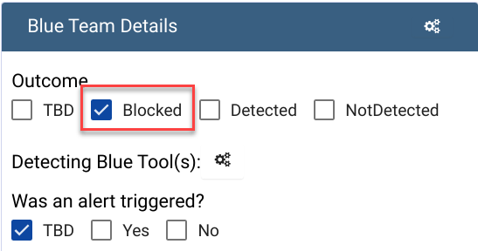

Note:

Alert Triggered will only apply for Blocked Outcome.

Filter:

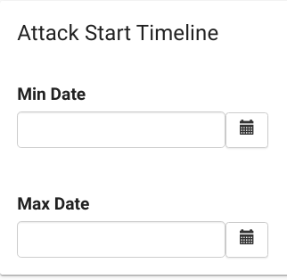

Field:

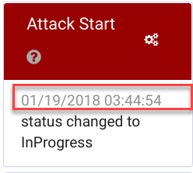

Note: MinDate inclusive, MaxDate exclusive

Filter:

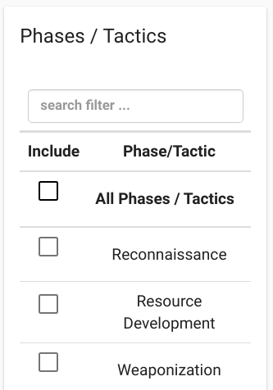

Field:

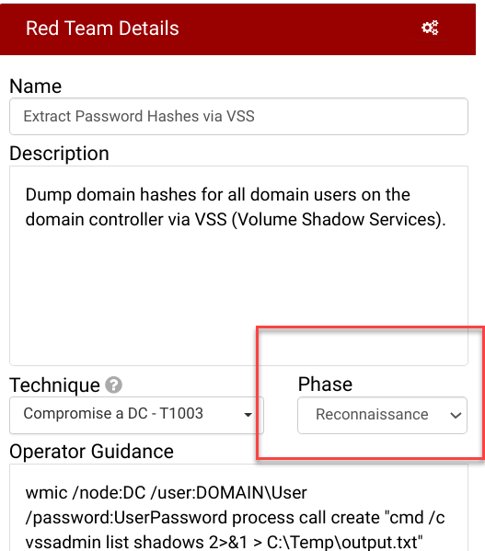

Filter:

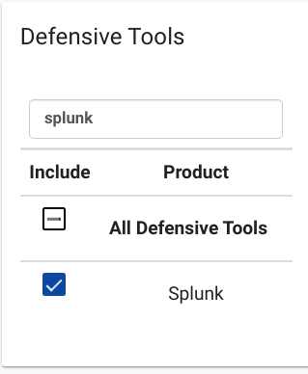

Field:

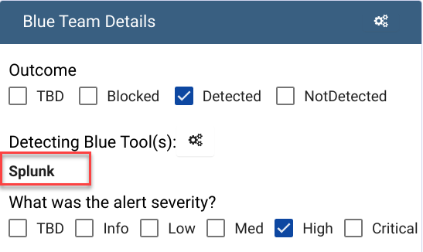

Filter:

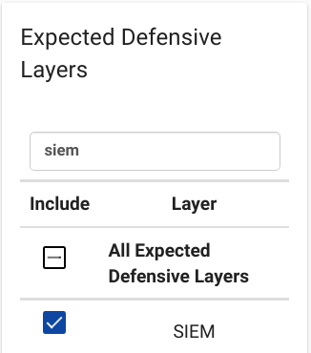

Field:

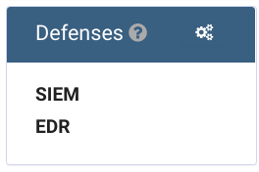

Filter:

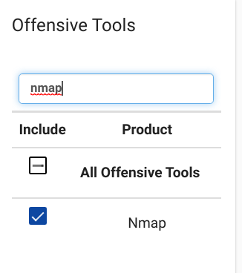

Field:

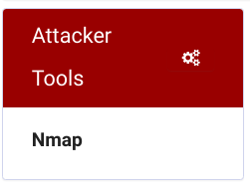

The last filter on the list is the “Latest” flag under ADVANCED / DataScope:

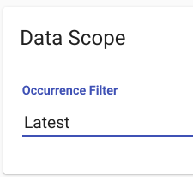

This is one of the more expensive queries and will cause data to load more slowly if you have larger datasets.

The purpose is to only show you the last run test case variant for each template type across all the selected Assessments and Campaigns. There is more extensive documentation on this here:  
<https://docs.vectr.io/HistoricalTrending/>